Online Keeping Children Safe (Level 1) training guidance
The Level 1 safeguarding training has recently been remodelled, in partnership with Bolton College, and moved to a new website. This document is designed as a guide to get users set up and started.
The training is now hosted and maintained by the college on their Moodle site here: https://www.boltoncc.ac.uk/boltoncouncil/login/index.php
You’ll be presented with following screen:
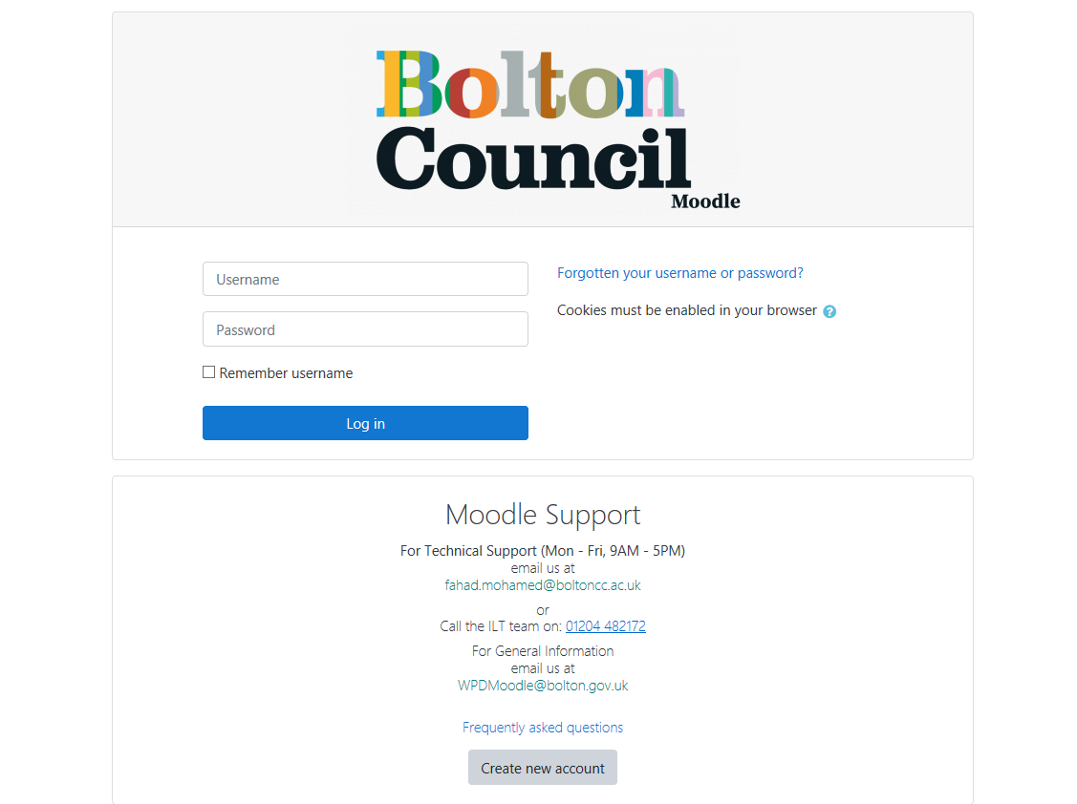
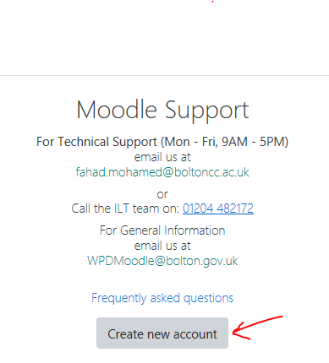
If this is your first time here, you’ll need to create a new account.
Once you’ve clicked on this and entered your details, you’ll receive an email. Please check your email and follow the instructions.
Note there are also FAQs here and contact details for support.
Once your account has been created and you’ve logged in, you will be taken to this page:
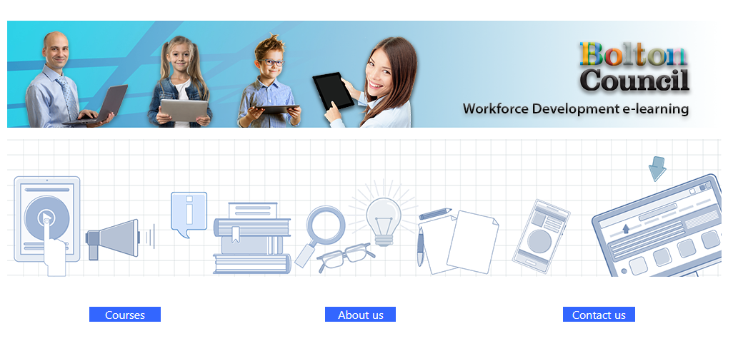

Select “Courses” and then choose “Keeping Children Safe”.
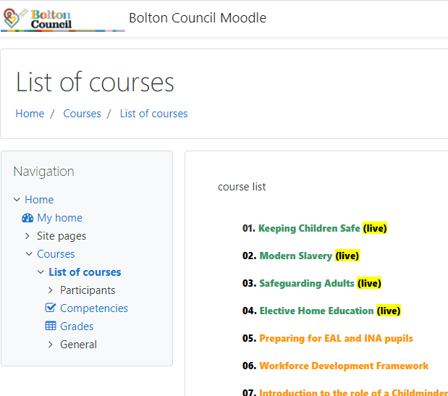

Click on ‘Enrol Me’.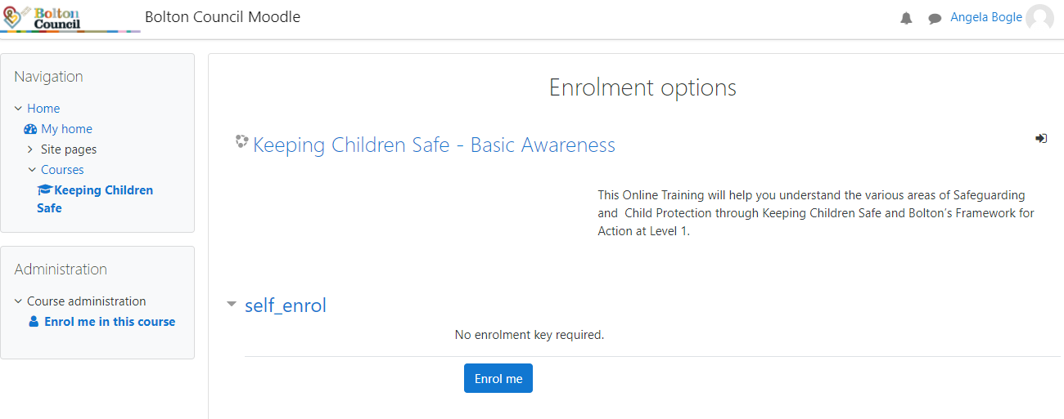
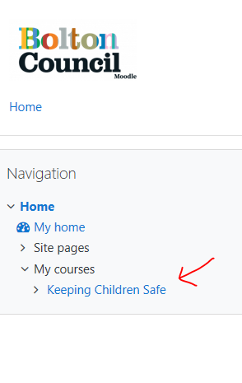
Click here and read the Introduction information.

Then click here to start the course.
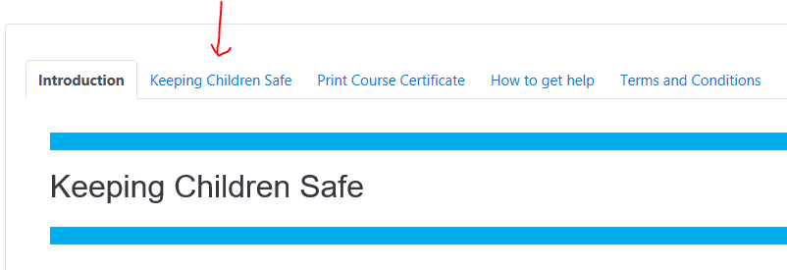

You’ll see a page like this. Please read the instructions and complete each of the 16 modules.
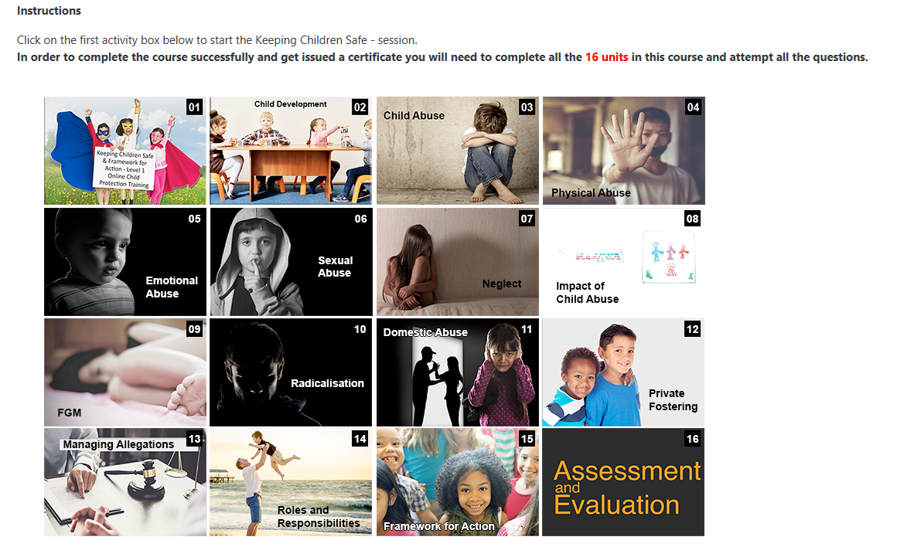

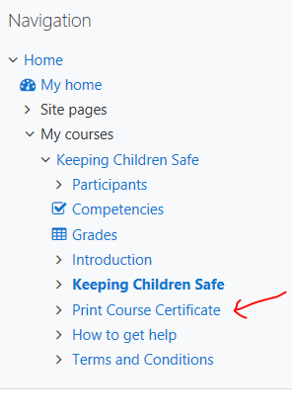
Once finished, you’ll be able to access your certificate.
After completion, you can log in anytime and access the certificate from here.

Produced by Adam Austin (Bolton Council, Safeguarding in Education Administrator) and Angela Bogle (Headteacher at Mytham Primary School and Chair of “Staying Safe”)

